POSE™ Personal Office Seating Evaluation
For an accurate assessment please complete all sections as fully as possible, especially measurements A-H
Confidentiality
All of the information we request is only used to help decide which chair model would be most suitable for you and your needs. All this information is kept strictly confidential.

For Quotations Only – Please Tick

Chair User Details
Contact for return of Quote & Report

Chair user location (inc dept & full address)
Name Tel Email

Please give a brief summary of your duties below

 | % Computer |  | % Writing |  | % Tel |  | % other

Do you use a footrest?
Do you have any allergies?
What is the shape of your desk?
What is the surface of your floor?
Would the user require arm rests?
Would the user require a neck rest?
Would the user benefit from memory foam?
Preferred height of back rest (if applicable)
Area of Pain | Tick | Please give details
Diagnosed
medical conditions
Lower Back
Middle Back
Upper Back
Coccyx / Sacrum
Neck
Shoulders
Elbow
Hand
Wrist
Fingers
Hips
Knees
Legs (Sciatica)
Other

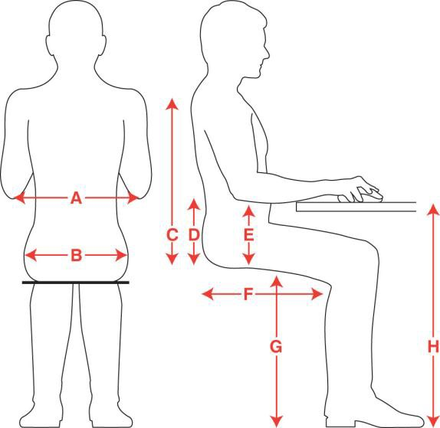

 | Measurements needed | cm
A | Width between elbows
B | Hip width when in a sitting position
C | Height from top of shoulder to surface of seat
D | Height from centre of lumbar curve to surface of seat
E | Height from underside of elbow to surface of seat
F | Depth from back of buttock to back of knee joint
G | Height from back of knee to floor, wearing shoe
H | Desk height
 | Weight (Stone & Lbs)
 | Height (Feet & Inches)

PLEASE RETURN THE COMPLETED FORM TO:
Back Care Solutions Ltd
Tel: 01772 330 333 Email: office@backcs.co.uk Website: backcs.co.uk
Post: The Old Bakery, Club Street, Bamber Bridge, PR5 6FN

